Name Lab Section

GTA Station #

8. S_{N}1: Substitution of triphenylmethanol

Post-lab report

Fill out the appropriate sections below.

A. Results for the formation of triphenylmethyl bromide

Amounts and units
Initial mass of triphenylmethanol (in g)
Initial amount of triphenylmethanol (in mol)
Initial volume of 33% HBr solution (in mL)
Initial mass of 33% HBr solution (in g; d = 1.354 g/mL)
Initial mass of HBr (in g)
Initial amount of HBr (in mol)
Limiting reagent
Theoretical yield of triphenylmethyl bromide (in mol)
Final mass of triphenyl bromide (in grams)
Final amount of triphenyl bromide (in mol)
% yield
Results (color observed) of Beilstein test in part A

Show all calculations.

B. Results for the formation of triphenylmethyl methyl ether

Amounts and units
Initial mass of triphenylmethanol (in g)
Initial amount of triphenylmethanol (in mol)
Initial volume of methanol (in mL)
Initial mass of methanol (in g)
Initial amount of methanol (in mol)
Limiting reagent
Theoretical yield of triphenylmethyl methyl ether (in mol)
Final mass of triphenyl methyl ether (in g)
Final amount of triphenyl methyl ether (in mol)
% yield
melting point (°C)

Show all calculations.

Complete the following questions in your own words. Then, fill out the appropriate sections below.
1. What product or products would you expect in part B of the experiment, if you used tert-butanol as your substrate instead of triphenylmethanol? Draw the product(s) of the reaction(s) in pen and indicate the type of mechanism(s) involved (S_{N}1, S_{N}2, etc.).

- How many resonance structures does the triphenylmethyl carbocation have? Draw (in pen) the overall resonance hybrid by placing partial positive charges (δ+) at all carbons over which the positive charge of the carbocation is spread.

There are __________________ resonance structures.

- The IR spectrum of triphenylmethanol is show below. Identify the major IR absorption frequencies as indicated in the following table. Consult your course textbook or other IR tables (for example: https://en.wikipedia.org/wiki/Infrared_spectroscopy_correlation_table ). Please note that the frequencies below should be single numbers, not ranges. Use the frequency of the center of the band at its strongest point. Then, on each spectrum, mark the characteristic bands at their strongest point with a tick mark and assign your peaks (write OH stretch, etc.).

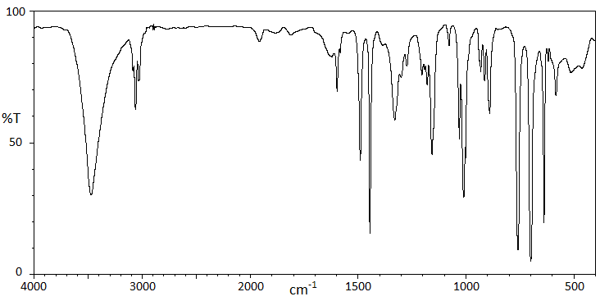

Vibration | Frequency (cm⁻¹) | Description (strong, medium, weak, broad, etc.)
OH stretch
C-H stretch aromatic
C=C stretch aromatic
C-O stretch

